SPATIAL ASSESSMENT OF 15-MINUTE URBAN ACCESSIBILITY
A GIS-Based Walkability Index for Central Ahmedabad

Author: Adithy Praveen – Ahmedabad University
Location Focus: Central Ahmedabad — Navrangpura, Ashram Road, Sabarmati Riverfront Corridor, Old City & Eastern Transit Nodes
Software Environment: QGIS 3.x — Network Analysis, Spatial Processing & Vector Analytics
Data Sources: OpenStreetMap (OSM) via QuickOSM; OpenStreetMap Standard Base Tiles
Date of Completion: August 2026

Core Summary
This report documents the spatial modelling, data architecture, and analytical findings of a 15-Minute City Walkability Index generated for the central metropolitan area of Ahmedabad, Gujarat, India. Using an integrated vector network analysis approach in QGIS, pedestrian catchment zones (network service areas) were modelled across five core amenity categories: daily retail and groceries, public transit nodes, educational institutions, healthcare facilities, and public green spaces.
By applying a hexagonal tessellation mesh across the study area and evaluating spatial intersections through a multi-criteria weighted index formula, the study identifies sharp micro-spatial disparities in pedestrian accessibility. Western core precincts — specifically Navrangpura, Paldi, Usmanpura, and the Ashram Road corridor — demonstrate optimal walkability (85–100 score), whereas eastern zones beyond the main railway corridor and peripheral zones exhibit pronounced spatial service gaps (0–45 score).

1. Introduction & Theoretical Framework

1.1 The 15-Minute City Paradigm
The 15-Minute City framework, popularised by Carlos Moreno, posits that urban residents should be able to access most of their daily essential needs — living, working, supplying, caring, learning, and enjoying — within a 15-minute walk or cycle from their doorstep. In rapidly densifying South Asian metropolises like Ahmedabad, evaluating urban accessibility through network-constrained pedestrian metrics offers vital empirical guidance for transport planning, mixed-use zoning, and equitable public service delivery.

1.2 Objectives
- Consolidate Spatial Infrastructure: Extract and clean high-resolution pedestrian networks and point-of-interest (POI) spatial datasets for Central Ahmedabad.
- Execute Network-Constrained Catchments: Model realistic 15-minute walking distance catchments along connected street topologies rather than unconstrained Euclidean buffers.
- Construct Hexagonal Grid Index: Partition the urban fabric into equidistant hexagons to evaluate multi-amenity overlap.
- Formulate Policy Insights: Identify primary spatial barriers (such as river corridors and rail line buffers) and recommend targeted urban interventions to bridge accessibility gaps.

2. Study Area Profile: Central Ahmedabad
The geographic domain of this study encompasses Central Ahmedabad along both banks of the Sabarmati River:
- Western Precincts: Navrangpura, Paldi, Usmanpura, Ambawadi, Gulbai Tekra, and the Gujarat University precinct. These areas are characterised by fine-grain street grids, mixed-use commercial corridors, high institutional density, and extensive BRTS/AMTS bus coverage.
- Central Riverfront Corridor: The Sabarmati Riverfront and associated arterial roadways (Ashram Road, Sabarmati Riverfront Road).
- Eastern / Historic Core: Khadia, Manek Chowk, Dariyapur, Shahpur, Asarwa, Sarangpur, Gomtipur, Rajpur Gomtipur, and the Kankaria Lake surrounding precincts.

3. Spatial Data Architecture & Preprocessing
All spatial layers were extracted via the OpenStreetMap API using the QuickOSM plugin in QGIS, bounded strictly to the active canvas extent of Central Ahmedabad to minimise computational overhead and storage footprint.

3.1 Primary Vector Datasets
Amenity / Network Category | OSM Key / Value Filtering | GIS Geometry Type | Master Layer Name
Pedestrian Road Network | highway=* (Primary, Secondary, Tertiary, Residential, Pedestrian, Unclassified) | Vector Line | Master Road Network
Daily Essentials & Retail | shop=* | Vector Point | Shops
Public Transit Nodes | highway=bus_stop, railway=station | Vector Point | Transit
Healthcare Facilities | amenity=hospital, amenity=clinic | Vector Point / Centroids | Healthcare
Educational Institutions | amenity=school | Vector Point / Centroids | Education
Parks & Green Recreation | leisure=park | Polygon Centroids | Parks
Table 1. Amenity and network layers extracted from OpenStreetMap.

3.2 Data Preprocessing Steps
- Geometry Standardization: Polygon amenities (such as large hospital campuses or public parks) were converted to single geometric points using the Vector → Geometry Tools → Centroids algorithm.
- Layer Consolidation: Duplicate POI outputs (e.g., individual shop layers and amenity_shop layers) were combined into master point layers using Vector → Data Management Tools → Merge Vector Layers.
- Network Cleanup: Minor road segments and unclassified shortcut pathways were merged with primary road vectors to ensure continuous topological connectivity across neighbourhood blocks.

4. Methodology & Analytical Workflow
1. Data Extraction & Extent Bounding (QuickOSM)
↓
2. Layer Merging & Polygon Centroid Conversion
↓
3. Network Service Area Calculation (1,200 m / 15 min)
↓
4. Hexagonal Mesh Generation (150 m Cell Size)
↓
5. Spatial Overlay & Field Calculator Scoring
↓
6. Graduated Cartographic Heatmap Rendering

4.1 Network Isochrone Modelling
Walking travel cost was set to a maximum threshold of 1,200 metres, corresponding to a 15-minute walk assuming an average urban walking velocity of 4.8 km/h (≈ 80 metres per minute).
Maximum walking-cost threshold | 1,200 metres (15-minute walk)
Assumed walking speed | 4.8 km/h (≈ 80 m/min)

Using the QGIS processing algorithm Service Area (from Layer), shortest-path network routes were calculated along the Master Road Network outwards from every POI in each master amenity layer, producing five 15-minute network catchments:
- Shops 15min
- Transit 15min
- Education 15min
- Healthcare 15min
- Parks 15min

4.2 Hexagonal Grid Generation
To eliminate corner-edge distance biases inherent in traditional square grids, a hexagonal mesh (“Walkability Grid”) was created using the Create Grid tool:
- Shape: Hexagon (Polygon)
- Dimensions: 150 m horizontal and vertical spacing
- CRS: EPSG:32643 (WGS 84 / UTM Zone 43N — Projected Metric System)

4.3 Multi-Criteria Weighted Scoring Algorithm
Each grid cell in the Walkability Grid was evaluated for spatial intersection against the five 15-minute service-area layers using the overlay_intersects() spatial function in the QGIS Field Calculator.

Binary Intersection Fields (Si ∈ {0, 1})
score_shop = if(overlay_intersects('Shops 15min'), 1, 0)
score_trns = if(overlay_intersects('Transit 15min'), 1, 0)
score_schl = if(overlay_intersects('Education 15min'), 1, 0)
score_hlth = if(overlay_intersects('Healthcare 15min'), 1, 0)
score_park = if(overlay_intersects('Parks 15min'), 1, 0)

Master Index Score Formula (WALK_INDEX)
WALK_INDEX = (S_{shop} × 30) + (S_{trns} × 25) + (S_{schl} × 15) + (S_{hlth} × 15) + (S_{park} × 15)

Weight Rationale
- Shops (30%): Highest daily operational frequency (grocery, food, personal supplies).
- Public Transit (25%): Critical anchor for city-wide mobility and non-motorised regional connectivity.
- Education (15%): Key determinant of family-oriented residential livability.
- Healthcare (15%): Crucial social safety net and emergency access factor.
- Parks / Recreation (15%): Essential for urban health, active recreation, and environmental well-being.

5. Analytical Findings & Spatial Interpretation
Based on the generated map output (15-Minute City Walkability Index — Central Ahmedabad), the spatial distribution of scores yields several key urban insights.
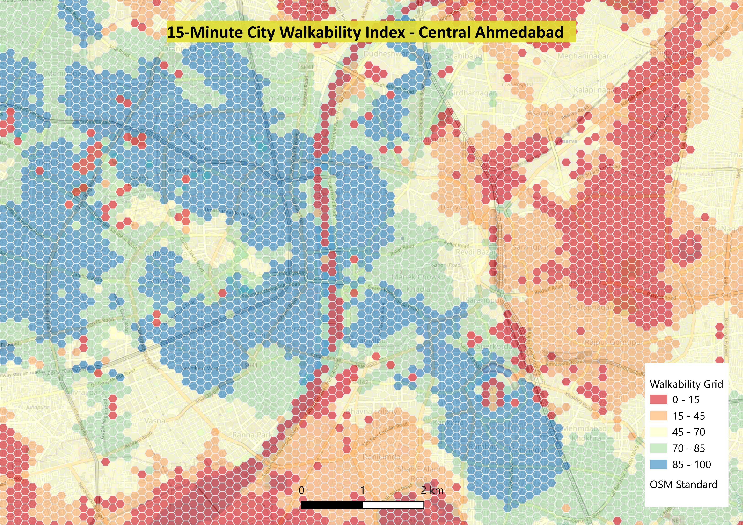
Figure 1. 15-Minute City Walkability Index — Central Ahmedabad (hexagonal grid, 150 m cell size).

Score Classification Legend
 | 85 – 100 | Optimal 15-Minute Walkability (all 5 amenities covered)
 | 70 – 85 | High Walkability (4 amenities covered)
 | 45 – 70 | Moderate Walkability (2–3 amenities covered)
 | 15 – 45 | Low Walkability (1 amenity covered)
 | 0 – 15 | Critical Walkability Deficit (no direct walkable access)

5.1 Western Core: High Walkability Dominance (70–100)
- Precincts across Navrangpura, Usmanpura, Paldi, and Ambawadi form a contiguous blue cluster (85–100 score).
- Key Drivers: High street network connectivity, dense integration of commercial shopfronts along arterial corridors (C.G. Road, Ashram Road), well-spaced BRTS bus stops, and a high concentration of schools and private clinics.

5.2 Kankaria Lake Cluster: Secondary High-Access Node
- A distinct southern cluster of high walkability (85–100, dark blue) appears surrounding Kankaria Lake, Rambaug, and Khokhra.
- Key Drivers: The recreational anchor of Kankaria Lake Park, combined with dense surrounding residential layout and transit stops, creates a highly self-contained 15-minute neighbourhood environment.

5.3 Physical Infrastructure Barriers & Service Drops
- Sabarmati River Bank Buffer: Linear bands of lower scores (0–45, red/orange) occur along portions of the immediate riverfront buffer, reflecting areas where non-pedestrian embankment zones disrupt continuous street grids.
- Central Railway Corridor Cut-off: A sharp vertical divide occurs along the north–south railway line passing east of the Old City (near Sarangpur, Asarwa, and Kankaria freight corridors). This rail line acts as a hard spatial severance barrier, causing adjacent hex cells to drop into the 0–15 (red) score range due to limited pedestrian underpasses and overbridges.

5.4 Eastern Periphery: Structural Accessibility Deficit (0–45)
- Moving eastward toward Asarwa, Gomtipur, Rajpur Gomtipur, and Amraiwadi, large continuous spatial blocks turn orange and red (0–45 score).
- Key Drivers: Industrial land-use legacy, wider block structures, lower density of formal public parks, and fragmented pedestrian infrastructure.

6. Urban Policy & Planning Recommendations
- Pedestrian Rail Crossings (Bridging the Railway Severance)
  - Issue: High walkability drops drastically around rail tracks near Asarwa and Sarangpur.
  - Action: Construct dedicated, well-lit pedestrian foot overbridges (FOBs) and underpasses at key severance points along the rail corridor to restore continuous pedestrian connectivity between the Old City and eastern precincts.
- Riverfront Pedestrian Permeability
  - Issue: Linear bands of low walkability occur along the immediate Sabarmati riverfront buffer, where embankment infrastructure interrupts continuous street grids and forces long detours to reach the opposite bank.
  - Action: Increase the frequency of at-grade pedestrian access points and signalised crossings along the Riverfront corridor, and extend the existing Riverfront promenade network with direct links into adjoining residential lanes rather than routing pedestrians onto arterial bridge carriageways.
- Replicating the Kankaria Neighbourhood-Anchor Model
  - Issue: High-walkability clusters in this study are consistently anchored by a single strong multi-purpose destination (a park, lake, or institutional cluster) surrounded by fine-grain residential streets, as seen at Kankaria Lake.
  - Action: Identify under-served hex cells in the 45–70 range that sit near an existing but under-utilised open space or public building, and prioritise these sites for small-scale park development, market upgrades, or community health posts to create new neighbourhood anchors at minimal land-acquisition cost.
- Eastern Periphery Amenity Densification
  - Issue: Asarwa, Gomtipur, Rajpur Gomtipur, and Amraiwadi show large contiguous zones of critical walkability deficit, driven by industrial land-use legacy, wide block structures, and a shortage of schools, clinics, and formal parks.
  - Action: Direct municipal capital works and public–private incentive schemes toward infill healthcare posts, primary schools, and pocket parks in these wards, prioritised using the WALK_INDEX raster to target the lowest-scoring hex cells first for maximum marginal accessibility gain per rupee invested.
- Last-Mile Transit Extension to Peripheral Wards
  - Issue: The 15-minute transit catchment thins sharply beyond the BRTS/AMTS-dense western core, leaving eastern and peripheral wards reliant on longer, unshaded walks to the nearest stop.
  - Action: Extend feeder bus or shared-mobility routes into the 0–45 scoring zones identified in Section 5.4, and pair new stops with shaded, paved footpath connections to nearby residential lanes so that transit access translates into genuine walkable coverage rather than isolated stops.

7. References
Moreno, C., Allam, Z., Chabaud, D., Gall, C., & Pratlong, F. (2021). Introducing the “15-Minute City”: Sustainability, resilience and place identity in future post-pandemic cities. Smart Cities, 4(1), 93–111.
C40 Cities Climate Leadership Group. (2020). How to Build Back Better with a 15-Minute City. C40 Knowledge Hub.
Institute for Transportation and Development Policy (ITDP). Pedestrians First: Tools for a Walkable City.
OpenStreetMap Contributors. (2026). OpenStreetMap [Vector and raster basemap data]. Retrieved via the QuickOSM plugin. https://www.openstreetmap.org
QGIS Development Team. (2026). QGIS Geographic Information System, Version 3.x. QGIS Association. https://qgis.org
QuickOSM Plugin Documentation. QGIS Python Plugins Repository. https://plugins.qgis.org/plugins/QuickOSM/
Ahmedabad Municipal Corporation (AMC) & Ahmedabad Urban Development Authority (AUDA). Municipal ward boundary and land-use reference data.

